**Capstone Project - Battle of the Neighborhoods**

**Introduction / Business Problem**

A Chinese technology company is embarking on global expansion and is looking for a startup setup in either Downtown of Toronto or Brooklyn of New York City. The company wants insight into the neighborhoods and local businesses in the cities so that its employees may have the optimum living standards and quality of life. This project will explore the similarities and dissimilarities between certain neighborhoods in the two cities, and determine which neighborhoods best fit the culture of the Chinese technology startup’s employees.

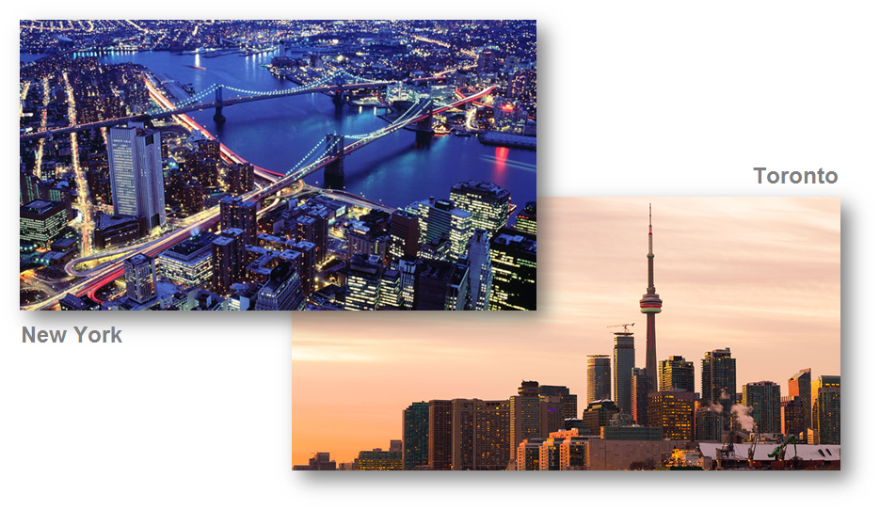

**Data**

The data used for this project will be acquired from the respective cities Wikipedia website pages. The datasets consists of the postal codes, neighborhood names, latitude, and longitude information for each neighborhood. Foursquare API search feature will be used to collect neighborhood venue information. Details about local venues and locality will be provide insight into the qualities of a neighborhood. In addition to Foursquare, various python packages will be used to create maps and machine learning models to further provide insights into our neighborhood battle project.

I used the following datasets from these websites:

* Toronto Neighborhoods - https://en.wikipedia.org/wiki/List_of_postal_codes_of_Canada:_M.
* Toronto Latitude and Longitude - http://cocl.us/Geospatial_data
* New York City neighborhoods - https://geo.nyu.edu/catalog/nyu_2451_34572
* New York City Latitude and Longitude = Python Geolibrar